# **ShaunPx1 Weekly Code Challenge**

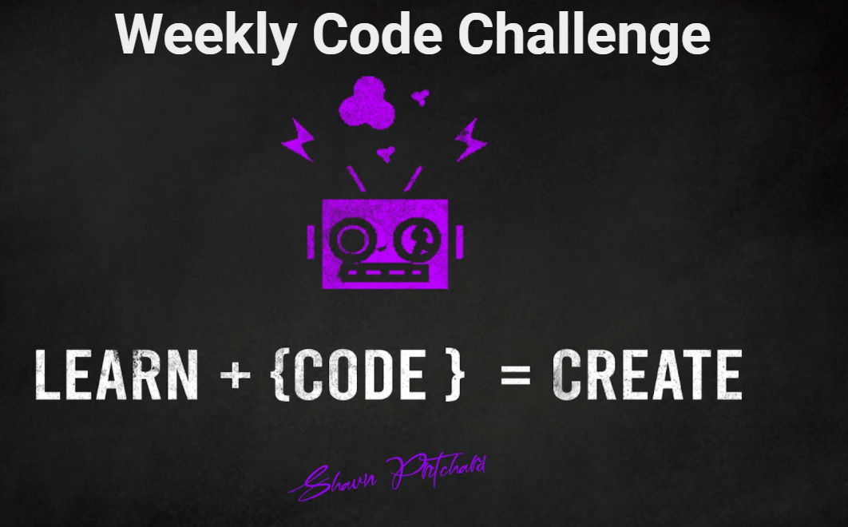

Welcome to my weekly could challenge group where each week I will be putting out a new code challenge and testing the limits of your problem-solving skills developer. If you'd like to see the videos and tutorials please visit my YouTube channel located at:

* [**ShaunPx1 Channel:**](https://www.youtube.com/channel/UC78cpbnaq-eeKGGHIEtUgdw)
* [**ShaunPx1 Creator Website:**](https://shaunp.live)

## **Submissions:**

1. You must build your code and upload it to GitHub or GitBucket (i.e. or equivalent)
2. You must post your link in the ShaunPx1 Facebook Group or Discord Server or YT Description.
3. !!! Important !!! tag your submission with the video number challenge using a hashtag
4. EX: ``` #1Challenge```

***WINNERS*** *will be announced each week or scheduled livestream on Youtube at ShaunPx1*

### **Submission Links:**

* [Facebook Submisions](https://www.facebook.com/shaunPX1/)
* [Discord Submisions](https://discord.gg/Mu52QeAE)

*Or you can drop your link in the YouTube video description for the challege*

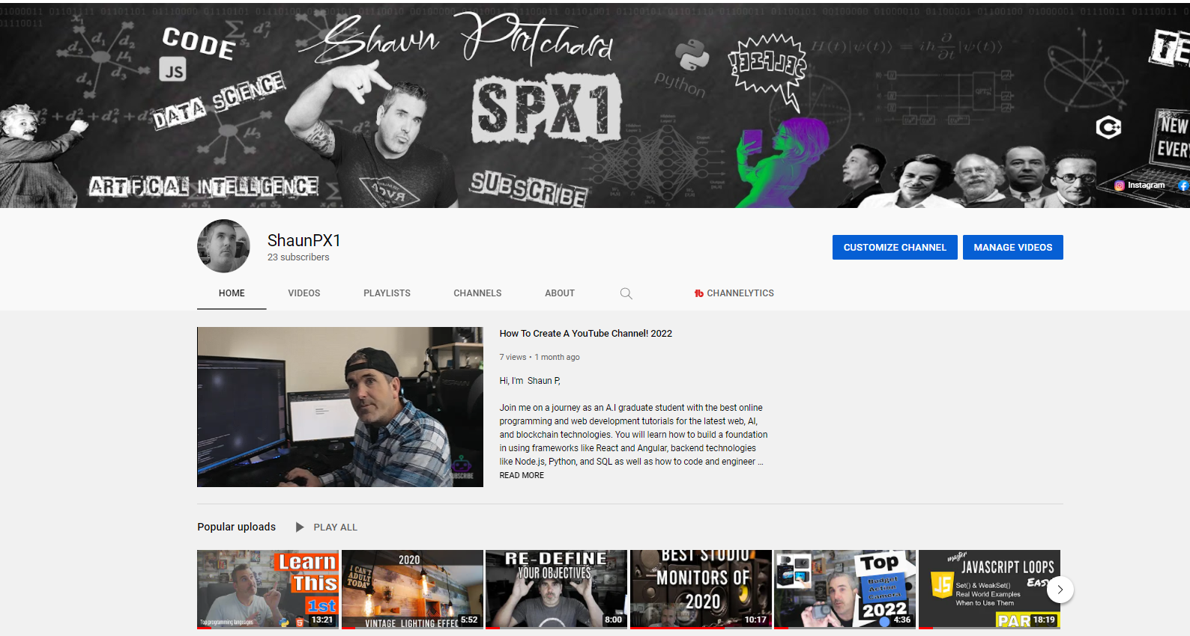

## **How this Works:**

Each week I'll be posting a new code challenge with specific parameters and limits that are located in the video of the challenge for that week. You can use either online or offline IDE and submissions must meet the requirements as stated in the video for a chance to win.

## **What we are looking for:**

***Best projects will have***....best designs, code from scratch, best data structure, clean tight code, animations, transitions, UX user experience, explications of how they solved the problem in logical format code design, and complexity.

## **Code Challenges:**

***To start a code challenge with the demo code, please go to this link:***

* [**2022 challengers go here**](https://github.com/shaungt1/ShaunPX1-Weekly-Code-Challenge/tree/main/Challenges-2022)**:**

*or go to the challenge directory above and find the directory with the weekly challenge in it for the specific data.*

**!!! NOTE: I will not be accepting Pull requests to the main branch unless specified in challenge!!!**

## **Prizes:**

There will be future giveaways such a physical or digital products but these are not guaranteed and just know that there might be sponsorships involved at some point in time with these giveaways. Entries will get recognition in an announcement video and live stream which will be posted scheduled every week/month based on release time.

## **Livestream:**

Live streams will be scheduled for YouTube and Facebook work orders and viewers can ask me live questions and in real-time having the ability to discuss code, data science and AI with me.

* [**ShaunPx1 LiveStream Channel:**](https://www.youtube.com/channel/UC78cpbnaq-eeKGGHIEtUgdw)
* [**ShaunPx1 Facebook Livestream:**](https://www.facebook.com/shaunPX1)